**Requirements and User Stories**

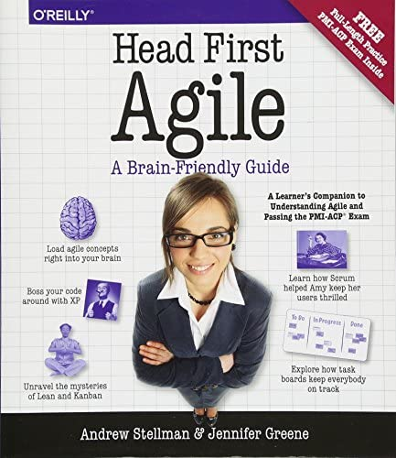

We needed to understand the process of Scrum, so we read the first chapters of a book called “Head First Agile: A Brain-Friendly Guide to Agile Principles, Ideas, and Real-World Practices”. Here we understood how other teams organize their work based on User Stories and we made them based on this type of cards:

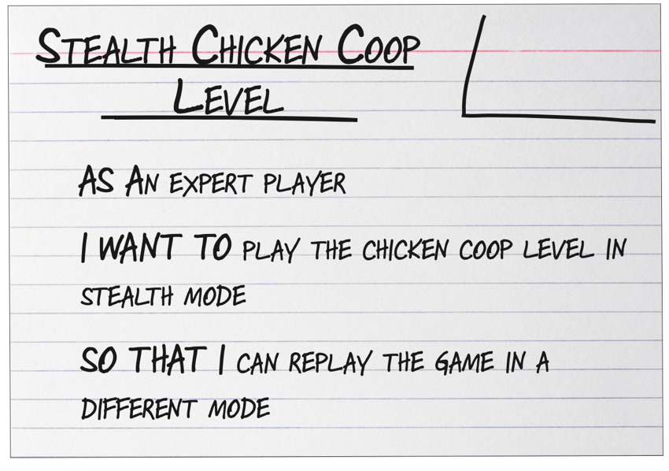

This are the User Stories we determined we needed to develop:

